**Software Engineering**

**Exam guide**

**Describe what a SW development process is (Roles, Documents, Activities…)**

**Complete diagram below**

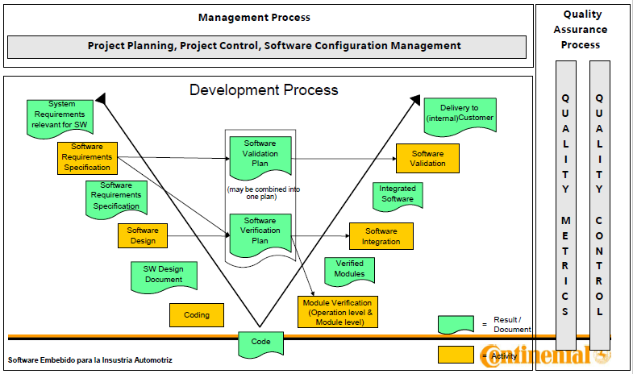

**What is a requirement? (1 point)**

(A) A condition or capability by a user to solve a problem or achieve an objective

***(B) A technical official document that clearly establishes all the characteristics and requirements that are necessary for creating components used for obtaining products.***

(C) A problem solving and planning process for a software solution

(D) The ideas of how a final product might be

**In engineering, what do specifications represent? (1 point)**

(A) A technical official document that clearly establishes all the characteristics and requirements that are necessary for creating components used for obtaining products.

***(B) The ideas of how a final product might be***

(C) A document that shows a general overview of the services the client has to receive

(D) A condition or capability by a user to solve a problem or achieve an objective

**Which of the following characteristics should the requirements have? (1 point)**

(A) Difficult, abstract and feasible

***(B) Actionable or feasible, measurable and testable***

(C) Simple, short and concise

(D) Useful, actionable and testable

**What is the definition of software design (1 point)**

(A) B and C

(B) Start implementing the software immediately and improve it later

***(C) A problem solving and planning process for a software solution***

(D) Is the process of documenting software requirements, implementation and test plans

**Specify the inputs for the software design process (1 point)**

(A) Requirements, Module description, Code

(B) Problem, Diagram, Code,

***(C) Software requirements specifications, module description and Software verification plan***

(D) Software requirements specifications, change requests and Software verification plan

**What is the purpose of the verification? (1 point)**

(A) Make sure the subject under test at least turns ON

***(B) Find errors on the subject under test using the results of earlier development phases***

(C) Inspection of the work performed by others

(D) Make sure that the project will not have any issue

**Which are the types of requirements? (1 point)**

(A) Complex, performance and defined

(B) Performance and non performance

***(C) Functionals and non functionals***

(D) Measurable, complex and functionals

**What is the main action of a “Checkout"? (1 point)**

(A) Create files and folders in the repository

(B) Address a conflict between different changes to the same document

***(C) Take an object from a repository to a work area in order to make changes on it***

(D) Update the repository from the changes of the work area

**What is the main action of a "Checkin/Commit"? (1 point)**

(A) Create files and folders in the repository

(B) Address a conflict between different changes to the same document

(C) Take an object from a repository to a work area in order to make changes on it

***(D) Update the repository from the changes of the work area***

**Put "F" (for False) or "True) depending on if the sentence is true or false. (4 points)**

_***F***_ To merge means: To look for differences between the repository and the working area to updated either repository based on work area or work area based on repository

_***F***_ A file that has not been checked out can be modified.

_T__ With versioning control system it is possible for two persons to modify the same file.

_T_ A branch can be done on a set of files so that two copies of those files may be developed at different speeds or in different ways independently of the other.

**Underline which are the characteristics of a versioning control system: (2 points)**

***- Stores configuration items into a database or repository.***

- Verify syntax of written code.

***- The ability to make changes over stored items***

- It is only used for source code files.

***- It has a historical record of performed actions over items or groups of items. (Enabling the possibility to roll-back to older versions, to view changes over time, etc.).***

**Configuration Management includes but is not limited to: (1 point)**

a)- Controlling the release and change of configuration items throughout the project.

- Coding and development of configuration items.

- Verifying the completeness of configuration items.

***b)- Recording and reporting the status of configuration items***

***- Controlling the release and change of configuration items throughout the project.***

***- Verifying the completeness of configuration items.***

c)- Verifying the completeness of configuration items.

- Recording and reporting the status of configuration items

- Fault detection and testing of configurations items

**Put "F" (for False) or "T" (True) depending on if the sentence is true or false. (4 points)**

_F_ An Update command replaces the files from the work area and stores them in the repository.

_T_ A check in will not update the repository.

_T_ With a versioning control system it is possible for two people to modify the same file.

_T_ A branch can be done on a set of files so that two copies of those files could be developed at different speeds or in different ways independently.

**Select which are the characteristics of a versioning control system: (1 point)**

- Stores configuration items into a database or repository.

- Verify syntax of written code.

- The ability to make changes over stored items

- It is only used for source code files.

- It has an historical record of performed actions over items or groups of items. (Enabling the posibility to roll-back to older versions, to view changes over time, etc.).

**Describe what the "Baseline" means on the context of a version control system. (1 point)**

Una revisión aprobada de un documento o archivo fuente desde el cual se pueden realizar cambios posteriores.

**Put "F" (for False) or "T" (True) depending on if the sentence is true or false. (1 point)**

_**_F**_ With versioning control system it is possible for two persons to modify the same file.

_**_T**_ A branch can be done on a set of files so that two copies of those files may be developed at different speeds or in different ways independently of the other.

_**_T**_ To merge means: To look for differences between the repository and the working area to updated either repository based on work area or work area based on repository

_**_T**_ A file that has not been checked out can be modified.

**In engineering, what do specifications represent? (1 point)**

(A) A technical official document that clearly establishes all the characteristics and requirements that are necessary for creating components used for obtaining products.

(B) The ideas of how a final product might be

(C) A document that shows a general overview of the services the client has to receive

**Which of the following characteristics should the requirements have? (1 point)**

(A) Difficult, Abstract, feasible

(B) Feasible, Measurable, can be tested

(C) Simple, Short, Easy to implement

**What is the definition of software design (1 point)**

(A) B and C

(B) Start implementing the software immediately and improve it later

(C) A problem solving and planning process for a software solution

**Specify the inputs for the software design process (1 point)**

(A) Requirements, Module description, Code

(B) Problem, Diagram, Code,

(C) Software requirements specifications, change requests, Software verification plan

**Define what action is better for the next situation: (1 point)**

**You are the manager for a project which is being developed. This project is in a state where all works well and the software will be released to the client. The client has submitted new changes for the future, but the client want to prototype a new feature added to his requirements before to establish it as an official feature.**

1. You must to negate the new changes and finish the project.
2. You must to submit to your team, to create a BRANCH of the project for the feature to prototype and create a TAG for the current project version.
3. You must to create a tag for the current project version and continue working in the TRUNK with the new changes submitted by the client.

**Define verification (1 point)**

(A) Make sure the subject under test at least turns ON

(B) Find errors on the subject under test using the results of earlier development phases

(C) Inspection of the work performed by others

**Define validation in your own words**

Proceso en el que se verifica el rendimiento y el comportamiento del software contra las especificaciones de SW asi como validar que el comportamiento general del sistema cumple todos los requisitos (en el entorno de validación que se utiliza)

**Define validation**

(A) None

(B) Make sure that the subject under test is not harmful for humans

(C) Make sure that the subject under test fulfill the specified software requirements

**When we refer to a document, source code or plan, that is a: (1 point)**

a) Software component

b) Generated configuration item

c) Configuration item

d) None of the above

**Select which are the characteristics of a versioning control system:**

- Stores configuration items into a database or repository.

- Verify syntax of written code.

- The ability to make changes over stored items

- It is only used for source code files.

- It has an historical record of performed actions over items or groups of items. (Enabling the posibility to roll-back to older versions, to view changes over time, etc.).

Que es configuration manager

Es el proceso de definir y controlar los elementos y procesos de un sistema, con el fin de generar reportes y documentación que ayude a gestionar de mejor manera el proyecto.

Porque deberiamos usarlo?

Distintas versiones de archivos, multiples personas involucradas con diferentes roles, control automatico de acuerdo a un metodo

Cual es el proposito?

Para mantener la integridad en las salidas y etradas del proyecto en todo el proceso de su diseño e implementación

Que puede estar bajo control?

Cualquier documento

Que debe estar bajo control?

Herramientas de diseño, codigos fuente, documentación y archivos que se produzcan.

Baseline

Serie de especificaciones que han sido formalmente analizadas por un grupo de trabajo, siendo la base del desarrollo

Release

La notificacion formal y la distribucion de una version aprobada.

Configuration Item

Puede ser codigo, documento, plan o conmponente de software en el proceso de configuration management.

Version Control

Baseline

Version aprobada del documento o el codigo fuente

Branch

Conjunto de archivos bajo una version de contorl, al momento de usar una nueva branch dos copias del proyecto se dividen y pueden ser desarrolladas a diferentes velocidades.

Checkout

Crea una copia local del contenido del repositorio

Commit/Checkin

Cuando los cambios de alguna copia son mezclados con el proyecto principal

Update

Mezcla los cambios que hayan sido hechos en una copia al repositorio.